Pedestrian gates - outside

To open the gates

Input the key code.
Turn the handle in direction of arrow.
Push the gate.

Close the gates behind you.

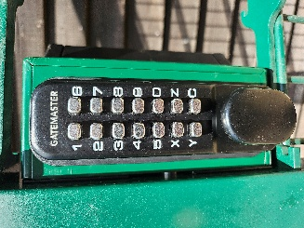

Press

Turn

To close
Pull firmly until it clicks

Gates should be closed at all times except on weekends when the Shop is open

